Final report Francesca Grisafi

Duration of project: 1

Project members: 1

Introduction 1

Aims 3

Hazelnut description 3

Material and methods 3

Procedures 3

Results 4

Exploratory analysis 4

Annual shoot (year n) 4

Lateral shoot (year n+1) 7

Apical shoot (year n+1) 10

GLMs 11

Laterals 11

Apical 20

Lpy 21

To Do: 24

# Duration of project:

October 2021 – March 2022

# Project members:

* Francesca Grisafi_ PhD student
* Evelyne Costes
* Frederic Boudon
* Jean Baptiste Durant

# Introduction

In recent decades, research in physiology has led to an understanding of the biological process underlying the behavior of many tree crops. Tree plants are complex organisms in which the growth is driven by different factors that interact with each other in different moments of tree life. Thus, to comprehend these interactions, complex experiments are needed to evaluate the effect of individual factors on the plant system. In addition, to try to understand what is the development during the time is often necessary to conduct experiments in more years. For these reasons, fields research is rather expensive and requires time that often is in contrast with the needs of the productive sectors. In recent years, the evolution of modeling has benefited from the increase in computer power and has allowed to creation of different sub-models that describe the functioning of individual organs to evaluate the possible interaction between them. Functional-Structural Plant Models (FSPMs) start from the simulation of the plant architecture, which is merged with the simulation of the physiological processes of each organ. This allows, to dislocate in the space the different organs and link their position with the physiological processes that occur within the other organs in the plant. This allows us to face managerial and biological problems from another perspective, thus allowing us to lead to innovative solutions.

# Aims

The goal of my period in Montpellier was to **analyze** and **code** a coarse architectural model of hazelnut. The model should address several questions:

1. How 1-year-old shoot is composed?

* There are some zones of the same type of bud?
* There are differences in the composition according to the length of the shoot?

1. What is the behavior of lateral shoots?

* How many of them developed?
* Where?
* From which bud? (vegetative or mixed?)
* How can we deal with multiple buds and multiple lateral shoots per node?

The way those questions are solved is through data **analysis,** in **Rstudio** from a different point of view (i.e. shoot scale, metamer scale, and bud scale) and with different statistical methods and models (i.e. exploratory analysis, Glms, Markovian models). Then, the resulting models were used in **Lpy** to **code** the growth of the plant.

# Hazelnut description

Hazelnut (*Corylus avellana)* is a plant with a bushy shape. In a 1-year old proleptic shoot, with an **alternate phyllotaxy**, are present different types of entities:

* **Mixed bud**: it has both vegetative and reproductive parts. It will burst into a vegetative shoot with the inflorescence (and then, nuts) in the apical position.
* **Vegetative bud**: it has just the vegetative part. It will burst into a vegetative shoot.
* **Blind node**: node with no buds presence
* **Sylleptic shoot**: this is a short shoot that develops in the same year of the parent. They also have, with an alternate phyllotaxy, the presence of Mixed and Vegetative buds. At the apical position, they have the **male inflorescence: the catkin.**

# Material and methods

A sampling of **120** 1year old shoots was collected **in 2020 in Perugia** (Italy). At the same moment of the collection, some **biometrical measures (i.e. diameter, length of the shoots, number of nodes)** were made as well as the qualitative and quantitative measures, at the node level, of the type of entities we could observe. Shoots were then aggregated into four **length classes (short, medium, long, very long)** according to their length in cm.

In 2021 the same analysis was repeated on the children’s shoots that were developed on the 1-year-old shoots targeted the year before.

In Montpellier, those data were analyzed and the results were used to code the first draft of hazelnut FSPM.

## Procedures

The first problem that was faced was the **definition of hazelnut elements** (e.g. sylleptic/proleptic shoots, mixed/catkins, lateral/apical, single/multiple buds)**.** Thus**,** common names were defined to describe the tree. Thus, the original dataset was re-designed into three ones according to the scale they were describing: shoot scale dataset; metamer scale dataset; bud scale dataset. Thus in the last two, the apical metamer/bud was distinguished from the lateral ones. The first lead to the **succession of the** shoot while the seconds lead to **lateral branches.**

First, **exploratory analyses** were performed, in **RStudio,** to understand the relationships between different variables inside the dataset (e.g.. length of the children ~ length of the parent, number of nodes ~ length of the parent, type of buds ~ rank node). Linear regression models, t-test, and proportion test were used to evaluate correlations or differences in mean/proportions. Exploratory analyses gave a first idea of the architectural features of hazelnut. Thus un diagram of the architectural dynamics was drawn. Following it, **generic linear models** and **multinomial regressions** were performed in **RStudio.** These models lead to equations that then were used in **Lpy** to link the different objects of the coarse architectural model.

# Results

## Exploratory analysis

### Annual shoot (year n)

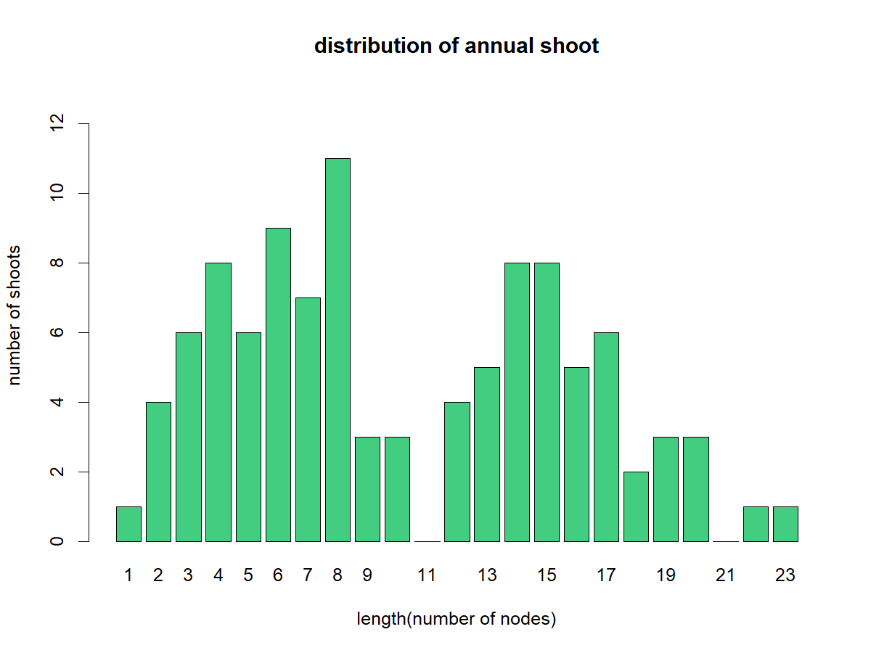The distribution of length (number of nodes) was **bimodal**. This could initially suggest merging some class lengths (Figure 1: e.g. Sh+Me, Lo+VLo).

Figure 1: distribution of shoots per length (number of nodes). Performed in the annual shoot of year n.

The proportion of different buds/sylleptic shoots in proleptic shoots showed no difference in the frequency of vegetative and mixed buds. However, they were both statistically different from Sylleptic and blind node frequency (Figure 2).

Figure 2: : percentage of lateral buds/sylleptic shoot whatever parental length. The difference in proportion was tested using the proportion test (RStudio).

The proportion of vegetative and mixed buds inside sylleptic shoots was not statistically different and was ~ 40-50%. (Figure 3).

Figure 3: percentage of mixed buds and vegetative buds in sylleptic shoots.

The proportion of different lateral buds/sylleptic shoots according to different parent class lengths, of proleptic shoots, showed a higher presence of blind nodes in short and medium shoots while a higher presence of mixed buds in long and very long shoots (Figure 4).

Figure 4: percentage of lateral buds/sylleptic per each parental class length. The difference in proportion per each bud/sylleptic, between classes, was tested using prop.test in RStudio.

The proportion of different lateral buds/sylleptic shoots according to parent rank node showed a higher presence of blind nodes in the basal part of the shoots while a higher presence of mixed buds in nodes near the tip of the shoot (Figure 5).

Figure 5: percentage of lateral buds in proleptic shoots according to rank node (1 is at the base of the shoot). Just nodes from 1 to 16 were analyzed because more frequent.

Hazelnut could have more than one bud per node. The analysis of multiple lateral buds per rank node showed that the majority of ranks have just one bud while sometimes there is a rank with two buds and rarely with three, four, or nine (Figure 6).

Figure 6: percentage of lateral multiple buds (1,2,3,4 or 9 buds in the same node) in proleptic shoots according to rank node (1 is at the base of the shoot). Just nodes from 1 to 16 were analyzed because more frequent.

The fate of lateral buds was investigated. In fact, mixed and vegetative buds could burst and become lateral shoots in year n+1. At the beginning of the shoot (nodes 1-4), there are more blind nodes and vegetative buds. This zone is followed by another (node 5-8) with the prevalence of sylleptic shoots. Nodes 9-16 are characterized by the prevalence of mixed and vegetative (Figure 7). This is in line with Figure 5. The combination of more than one bud, if present is in the middle part of the shoot and at the end.

Figure 7: percentage of different lateral buds combination in proleptic shoots according to rank node (1 is at the base of the shoot). Just nodes from 1 to 16 were analyzed because more frequent.

The same analysis is meaningless in sylleptic shoots because some data are missing: sylleptic length, and number of nodes in sylleptic. Due to that, the number of combinations inside sylleptic seems bigger than it is in reality. This is further work that could be interesting to invest in.

### Lateral shoot (year n+1)

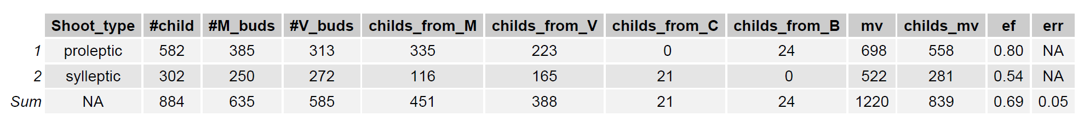In year *n+1*, at each metamer of the **parent shoot** (annual shoot), at least one **lateral shoot** is produced from **vegetive buds and/or mixed lateral buds**. (Table 1)

Table 1: description of lateral shoots born from buds in proleptic or sylleptic parental shoots.

The relationship between the length of **proleptic parent** and the length of lateral children showed that the majority of new shoots are short shoots. Some medium shoots are observable from buds in very long (>40cm) parent shoots (Table 2,Figure 8, Figure 9).

Table 2: description of lateral shoots born from buds in proleptic or sylleptic parents.

Longer shoots (“Me” class, yellow-colored) are more present in higher rank nodes (i.e. longer parental shoots) (Figure 9). It is also noticeable how the majority of new shoots are single “Sh”, a few double “Sh” are present at the beginning-middle part of the parent shoot (Figure 8).

Figure 8: percentage of lateral child (from buds in PROLEPTIC) class length per each parental class length. The difference in the proportion of Medium lateral children was tested using prop.test (RStudio).

Figure 9: percentage of different lateral shoots combination in proleptic shoots according to parental rank node (1 is at the base of the shoot). Just nodes from 1 to 16 were analyzed because more frequent.

The same analysis is meaningless in sylleptic shoots because some data are missing: sylleptic length, and number of nodes in sylleptic. Due to that, the number of combinations inside sylleptic seems bigger than it is in reality. This is further work that could be interesting to invest in.

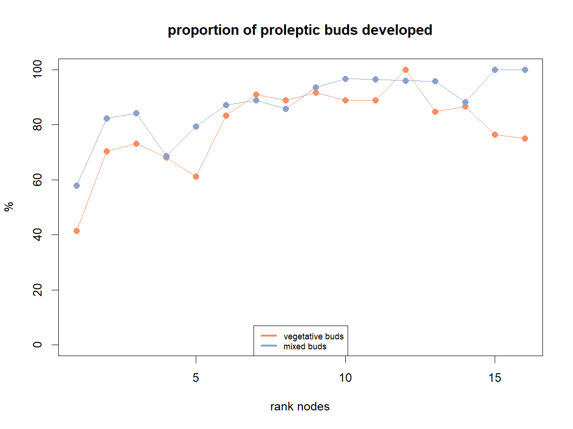The percentage of bursting M or V increases with the rank node (Figure 10).

Figure 10: percentage of buds (vegetative or mixed) that sprouted, according to parental rank node (1 is at the base of the shoot). Just nodes from 1 to 16 were analyzed because more frequent.

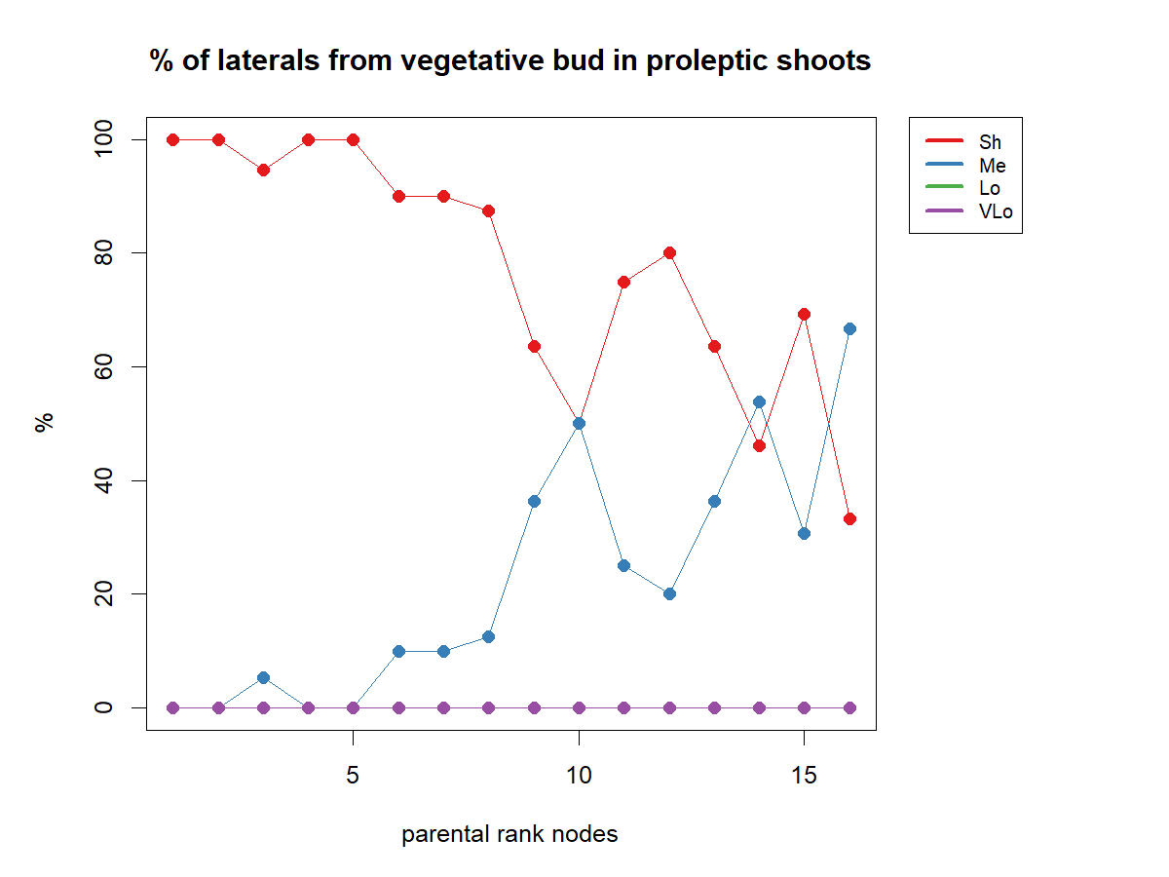The length of new shoots from Mixed or Vegetative buds, in proleptic shoots, was related to parental rank node (Figure 11, Figure 12). This graph showed that longer children's shoots derived rather from vegetative than mixed buds.

Figure 11: frequency of lateral shoot class length, from vegetative buds in proleptic shoots, related to parental rank node (1 is at the base of the shoot). Just nodes from 1 to 16 were analyzed because more frequent.

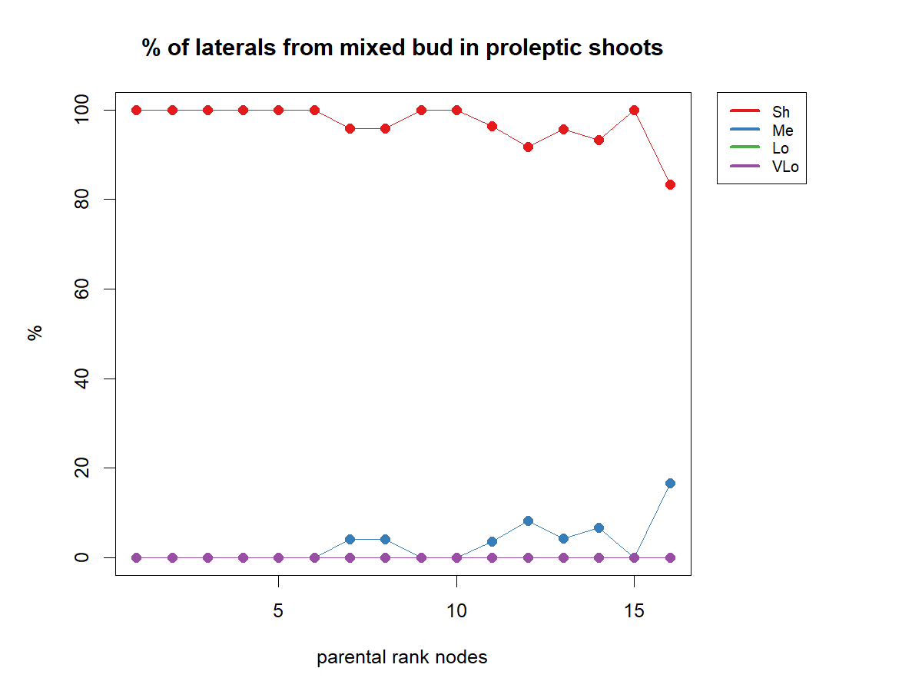

Figure 12: frequency of lateral shoot class length, from mixed buds in proleptic shoots, related to parental rank node (1 is at the base of the shoot). Just nodes from 1 to 16 were analyzed because more frequent.

### Apical shoot (year n+1)

Apical buds are almost all vegetative or mixed (Figure 13)

Figure 13: frequency of apical buds. The difference in proportion was tested using prop.test in RStudio.

All of them burst and the relationship between the length of **proleptic parent** and the length of apical children showed that the majority of successive shoots are short shoots for shorter parents, while their length increase with the increase of parent length (Figure 14)

## GLMs

Figure 14: percentage of apical child class length per each parental class length. The difference in proportion was tested using prop.test (RStudio).

### Laterals

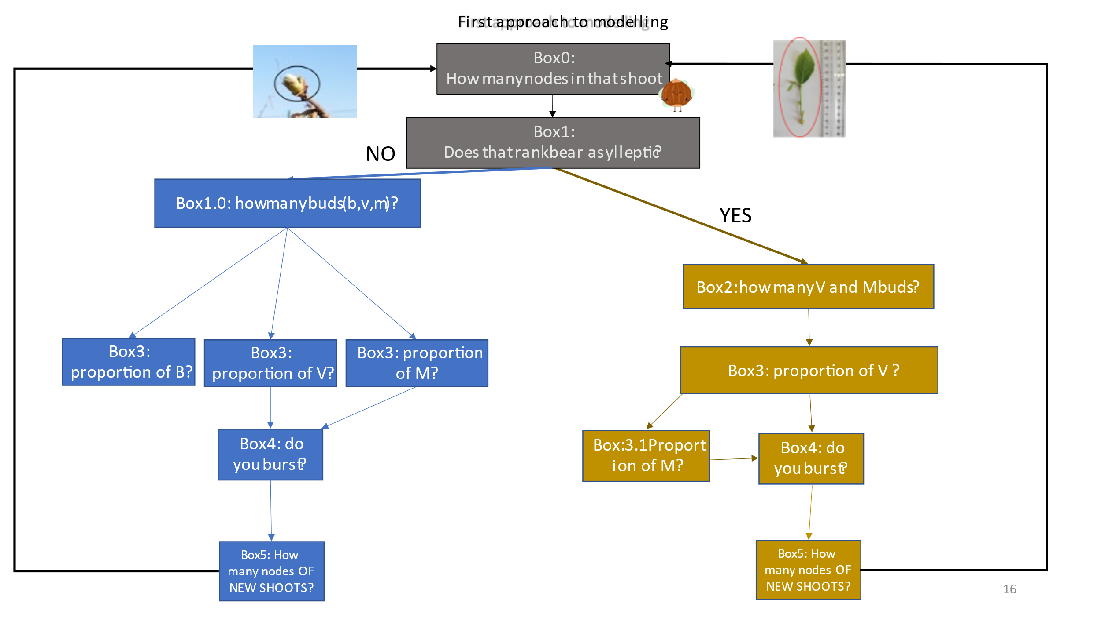From the exploratory analysis was possible to draw the first logical scheme that drives the growth of hazelnut plant (Figure 15).

Figure 15: logical diagram to model hazelnut growth. Gray boxes are the common ones. Blue boxes are followed in the case of bud in proleptic shoots, while yellow boxes are followed in the case of bud in sylleptic shoots.

The first step is to answer the question “**how many nodes has that shoot?”** Then **“does that rank bear a sylleptic?”**. If the answer is **YES** the simulation will follow the blu boxes, alternative, it will follow the yellow. In both cases the questions regarding:

* Number of buds;
* Proportion of buds;
* Probability of bursting of M and V;
* Number of nodes of new shoots

This last question is the one that closes the loop and connects the new shoots' information with the next steps. For each box, the dependent variable was explained by some predictors using *glm,* *multinomial regression,* or *non linear models*in RStudio. Each model tested the relation between the dependent variable (i.e. Number of MandV buds) with many predictors (i.e. Parent length, number of nodes, distance from median node). Every time that one parameter resulted not significant it was deleted from the equation and the model was run again. When the best model was found (e.g. all the predictors had at least 1 star) permutation models with, significance level put as 0.001, were done. Then the final model was chosen according to the best AIC.

#### Box0: how many nodes are in that shoot?

The relationship between the length of annual shoots and the number of nodes was significant (p<0.001) (Figure 16).

Figure 16: relationship between length(cm) and number of nodes in annual shoots. length(node)=1.81*length(cm)0.57.

#### Box1: does that rank bear a sylleptic?

Because sylleptic shoots were almost in the median zone along with the parent shoot (Figure 5), the distance from each node to the median one was computed per shoot. Then, the absolute value for this parameter was calculated. The percentage of sylleptic shoots decreases with distance from the median node (Figure 17)

Figure 17: probability of having sylleptic shoots according to distance from parental median node. y= 1/1+e(-(0.4315-0.2672*x)).

#### Box2_sylleptic: how many V and M buds?

The average sum of mixed and vegetative buds, in sylleptic shoots, was related to parent length and distance from parental median node (Figure 18)

Figure 18: average sum of mixed and vegetative buds in sylleptic shoots related to parent length(cm) and distance from median node. Y=e(0.613354)+e0.016119*parent_length(cm)+e-0.132113*median_distance.

#### Box3_sylleptic: what is the proportion of V?

Analysis with glm was conducted. They reported a correlation with parent length in nodes (Figure 19)

Figure 19: glm of proportion of V with parent length nodes as a parameter.

However, the model underestimated the proportion of vegetative buds for short shoots (left part of the graph Figure 20). Moreover, the parameter parent length is not the length of the sylleptic but of the parent that bears it. Because of those reasons the model was discarded and was assumed that the proportion of V buds was constant (0.55±0.02) as suggested in Figure 3. Accordingly, the proportion of M buds was computed as 1-%V.

#### Chart, histogram Description automatically generatedBox4_sylleptic: do you burst?

Figure 20: graph is drawn using coefficients of glm in Figure 19. The pink line represents predicted values, while blue lines are real ones.

The probability of bursting was computed with a glm with interaction(Fig.21). This strategy was chosen because the probability of bursting was influenced by the fate of the bud itself and the presence of other M or V buds in the same sylleptic (Figure 21).

Figure 21: summary of glm with interaction to compute the relationship between the probability of bursting and the chosen predictors (i.e. fate, other M buds and fate, other V buds and fate).

The results show that if the bud is V the probability of bursting decreases in the presence of other V and if the fate is M the probability of sprouting decreases if there are other M in the same sylleptic (Figure 22).

Figure 22: graph showing the results of glm. The left side shows that if the bud is M and there are other M, the probability of having a new shoot (i.e. probability of bud bursting) decreases steeply than if there are other V. The opposite happens if the bud Is V

#### Box5_sylleptic: how many nodes of new shoots?

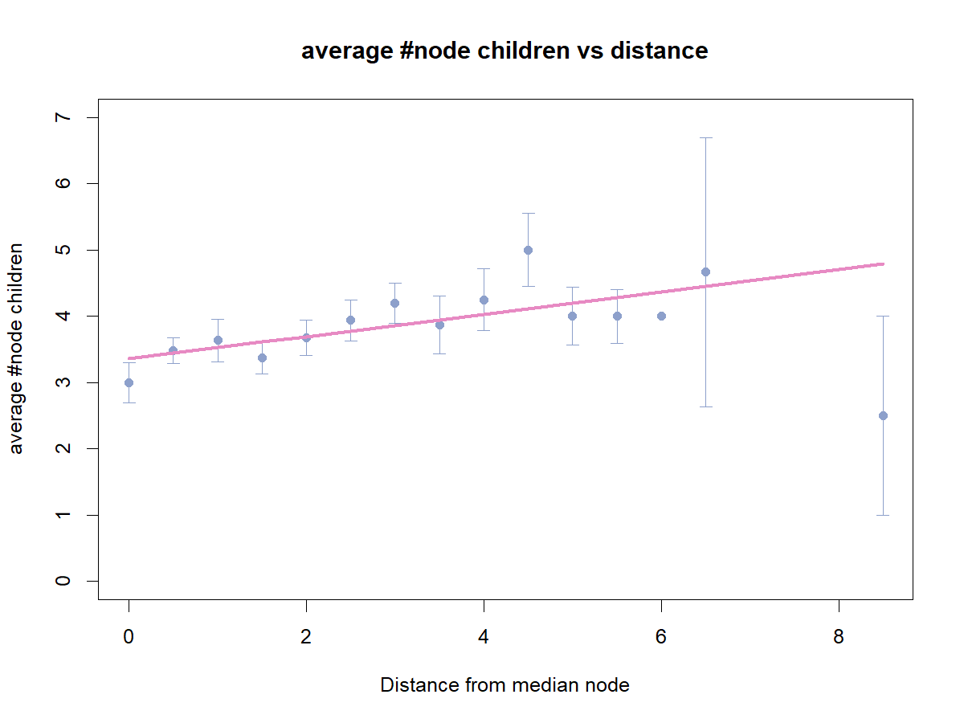Number of nodes of new shoots was related to distance from median node (Figure 23).

Figure 23: Relationshio between new nodes and distance from median node. in Sylleptic shoots. y=3.36+0.17x (R2=0.02; p<0.005)

#### Box2_proleptic: how many B, V, and M buds?

The total number of buds (B, M, V) in proleptic shoots was not related to anything (Figure 24)

Figure 24: glm with length(cm), distance from median node, rank node, and length in nodes as predictors. None of them was significant.

Thus, we decided to take the number of buds as a random number in a Poisson distribution with λ equal to exp(0.11689) and k equal to 1 (because the node we are investigating is just 1) (Figure 25)

Figure 25: null glm to have the intercept. The exponential of the coefficient is λ in the Poisson distribution.

#### Box3_proleptic: what is the proportion of V, M, and B?

To answer this question a multinomial logistic regression was done (Figure 26). Rank node was the best variable to describe the proportion of V, M, and B.

Figure 26: multinomial regression to evaluate the proportion of V, M, and B, according to the parental rank node.

The results were not satisfying (Figure 27). Especially for the final rank nodes where predicted M buds were more than predicted V, while, using real data V is more than M (Figure 27). **Is it because I made multinomial regression considering rank node as a continuous variable(type=integer) instead of categorical (type= factor)**NO!!!

#### Chart, bar chart, histogram Description automatically generatedBox4_proleptic: do you burst?

Figure 27: proportion of V, B, and M buds according to rank node, in proleptic shoots. Pr(B)=e(0.88-0.43*x)/(1+e(0.88-0.43*x)+e(-0.05+0.03*x)); Pr(M)=e(-0.05+0.03*x)/(1+e(0.88-0.43*x)+e(-0.05+0.03*x)); Pr(V)=1-Pr(B)-Pr(M).

The probability of bursting was computed with a glm with interaction(Figure 28). This strategy was chosen because the probability of bursting was influenced by the fate of the bud itself and the presence of other buds (M or V)in the same node.

Figure 28: summary of glm with interaction to compute the relationship between the probability of bursting and the chosen predictors (i.e. fate, sibling buds (other M+ other V in the same node).

The results show that if the bud is V or M, the probability of bursting decreases in the presence of other buds (dibbling buds) at the same node. The V buds highly decrease the probability of bursting When distance increase. The probability of bursting increases, both for V and M when the length increase (Figure 29).

#### Graphical user interface Description automatically generatedBox5_proleptic: how many nodes of new shoots?

Figure 29: graph showing the results of glm. On the left upper side, it is possible to see that the bursting of both V and M buds is affected by the presence of sibling buds in the same node. The distance from the median rank node affects more V buds, while lengt

The number of nodes of new shoots is related by the cumulative effect of parent length and fate (Figure 30)

Figure 30: Relationship between number of nodes of new shoots and parent length.fateV: y=2.39+0.05*length; fateM: 3.34+0.02*length. (R2=0.10. p<0.001)

### Apical

#### What is the fate of apical bud?

Apical buds are always 1 per shoot and their fate can be C, M or V (Figure 13). To answer this question, the possibility of being C was excluded. Because this imply that the shoot is sylleptic. While, at the beginning of our wxperiment, we supposed that every shoot was a proleptic shoot. Thus, proportion of apical V and M was computed (Figure 31).

Figure 31: proportion of apical M and V

Glms were tested to evaluate if there was a link between proportion of each fate and some predictors such as length of the shoot, number of nodes. The test showed not significance for any of the tested predictors. Thus a nul model was run in order to evaluate the proportion of each fate (Figure 32).

Figure 32: null binomial glm model to evaluate the probability of having V or M

Proportion of each fate was computed with the following formula: Pr(M)=e(-0.27)/(1+e(-0.27)); Pr(V)=1-Pr(M). Thus, apical bud fate will be computed accordind to the binomial distribution with size=1; n=1; and probability=0.57,0.43.

#### What is the length of apical children?

The number of nodes of the new shoots born from apical buds (from M or V) was linearly related with number of nodes of parent shoot (Figure 33).

Figure 33: relationship between number of nodes of new shoots from apical buds and number of nodes of parental shoot. y=3.95+0.12x (R2=0.06. p<0.05)

## Lpy

Coding the model in Lpy implies the use of all the functions and models that I already showed.

In the beginning, the library is imported and some fixed variables are declared. We decided to start with a fixed length of 70cm, internode length of 0.5cm, and diameter of 0.4mm (Figure 34)

Figure 34: first lines of hazelnut.lpy code

Than the code continues describing Box0 and Box1 (Figure 35, Figure 36, Figure 37)s

Figure 35: The relationship between length cm and length nodes (Figure 16); The relationship between length cm and diameter (missing figure); Box1:Does that rank bears a sylleptic?Computed Probability (Figure 17); Box1:Does that rank bears a sylleptic?Probability fro m binomial function (Figure 17); Box 2-4 of sylleptic and proleptic are described later in the code (Figure 31 and Figure 32)

Figure 36: Box2_sylleptic: how many buds? (Figure 18); Box2_sylleptic: how many buds? (Figure 18);Box4_probability of bursting? (Figure 21);Box4_ probability of bursting? (Figure 21)

Figure 37: Box2_proleptic: how many buds? (Figure 24); Box3_proleptic: bud’s proportion? (Figure 26) ; Box4_probability of bursting? (Figure 27); Box4_ probability of bursting? (Figure 27)

We added the **time** in the model. To do so, two variables and a function were created. The variables were: *currentime* to start the simulation and *lasttime* to stop the simulation. They were 2021 and 2023 respectively. The function StartEach() divides the number of current iterations by 2. If the result is an integer number and the number of iterations is more than 0, the time is increased by one (Figure 38).

Figure 38: code of hazelnut.lpy to add the time in the simulation.

After that, the modules are declared (Figure 39)

Figure : modules of hazelnut.lpy

Then the l-system starts: it is composed by axiom(Figure 41), derivation length(Figure 41), production(**Error! Reference source not found.**), interpretation.

The ProlBud, defined by length, *burstdate* and mixed does this. If the date of burst is less or equal to currentime, it will produce for variables: the number of nodes according to eq. in Figure 35; diameter according to eq. in Figure 35, the internode length dividing length per number of nodes, the median rank. Then, for each rank (computed as the number of rank +1) it will produce an Internode with length equal to *internodelength* and diameter equal to the diameter. Then it will compute the distance to median rank and the probability that internode bears a sylleptic according to eq in Figure 35. If the answer is “**yes there is a sylleptic**” then, it will compute the length of the sylleptic (we chose the length of sylleptic equal to internode length because it is **missing data**). It will then compute the number of mixed and vegetative buds according to eq in Figure 36. Then it will create a branching sylleptic (defined later). If the answer is “**no there is not a sylleptic**”then it will compute the number of buds according to eq. inFigure 37; the number of siblings according to eq. in Figure 37, and the fate according to eq. in Figure 37. for each bud, if it is Blind, it will create a blind node (defined later), otherwise it will compute the probability of bursting from eq. in Figure 37 and then if it is a V it will create a Vegetative bud (defined later) or an M bud (defined later). In the end, it will produce an apical bud. If the bud was mixed it produces a nut, otherwise, it will do the succession (**missing data**). Syl was produced in **Error! Reference source not found.** and now it is explained. It is defined by *length, number of m and v buds, and burstdate*(Figure 42). If burstdate is less or equal to currentime, internode length will be computed. Diameter is calculated according to eq in Fig. 30. The number of vegetative buds is a fixed number (Figure 20) and mixed buds are computed as 1-%V. For each bud in the list, the internode will be produced, as well as V or M buds. In the end, there is a Catkin(defined later).

Figure : lpy code

Figure 41: Axiom and derivation length. The axiom will produce Info (It will be declared in the “production” section) and a ProlBud(It will be declared in the “production” section) with three parameters: trunklength, currenttime, False. The derivation length is equal to (lasttime(2023)+1-currentime(2021))*2.

Figure : lpy code

These are the graphical rules that the code should follow. Info will display on the screen the current year. Internode is a cylinder of length, l, and diameter, d. Nuts are a sphere of diameter of 0.5. Catkin is a cylinder curve color yellow. Blind node will draw nothing. ProlBud is a green sphere of diameter 0.12.

Figure : Interpretation

# To Do:

1. ~~Analysis fro box5 for proleptic and sylleptic~~
2. Evaluate the length distribution on hazelnut
3. ~~Glms for apicals~~
4. Continue lpy